GreenThreads Denver Store #13
Executive Brief: Closing the Sales Associate Staffing Gap Before Launch
To: Marcus, CEO; Jennifer, CFO
From: Yasmine Lopez, HR Operations Liaison
Date: September 10, 2026
Decision Requested: Approve a phased Sales Associate pay increase and authorize HR to close the remaining seven role vacancies ahead of the November 1 launch.

Recommendation
Raise Sales Associate pay to $18.25/hour immediately for all 8 seats, track offer acceptance for 30 days, and escalate to $19.75/hour if declines don't improve — guaranteeing $19.75/hour at the one-year mark regardless. Hold September 28 as the start date. This directly addresses the leading cause of lost candidates on the role the Denver launch can least afford to leave short, without requiring the full budget ask on day one.

The Problem
Denver's 14-person floor team is half-staffed with the launch window closing. Sales Associate — 8 of the 14 seats, and the highest-turnover role in the store — is the critical gap: only 2 of 8 seats are filled, and only 2 of 11 offers extended were accepted (18.2%). Our own Employee Handbook requires hourly retail pay at or above the local market median. The Sales Associate offer sits well below that standard, and applicant data confirms the cost directly: pay is the single most common reason candidates decline (5 of 9 declines), with a mismatched start-date timeline compounding the problem (3 of 9 declines).
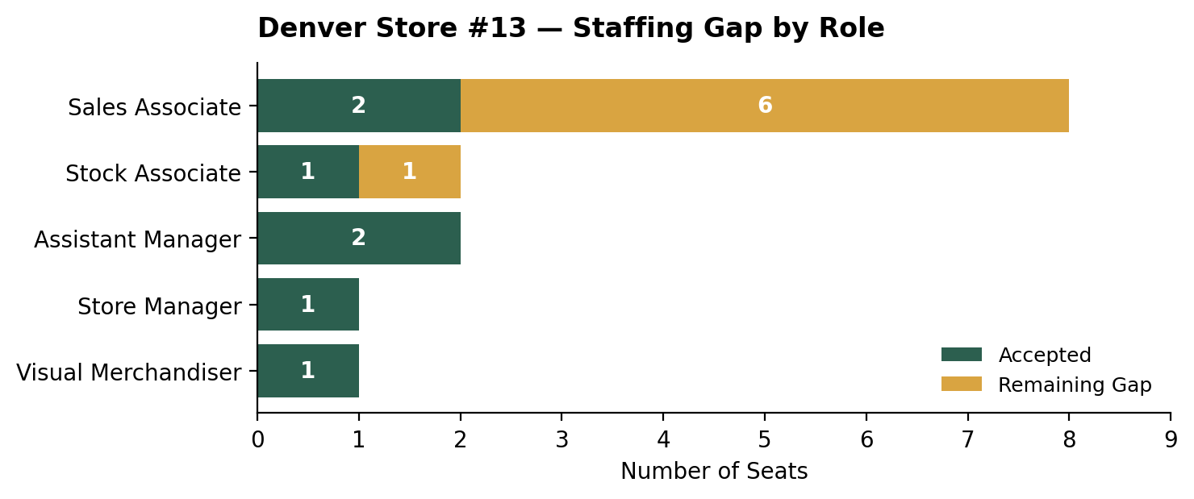
Source: GT_HR_Denver_Applicants.csv. 14 target seats across 5 roles; 7 accepted, 7 remaining.

The Quarter, As One Story
The problem: Open Denver on schedule without adding corporate headcount. Our functional analysis (HW#1) identified Sales Associate hiring as the single highest-stakes bottleneck HR could address with the recruiting capacity we already have.
What we did with AI: We cross-referenced the offer letter, Employee Handbook, and job posting against 148 applicant records (HW#2), confirming GreenThreads wasn't following its own written pay policy for this role — not as a guess, but traced to three independent sources agreeing. We then built a custom AI assistant (HW#4) so HR can keep asking these questions directly from the data, without needing a one-off analysis every time.
What we found: Policy, practice, and outcome all point the same direction. The Handbook sets the rule; the offer breaks it, by the largest margin of any role; and the decline data shows candidates responding exactly as the Handbook itself predicts a pay gap would cause.
What we recommend: A phased pay correction that closes the largest documented gap without requiring the full budget ask before Finance has confirmed funding — detailed below.

Cross-Function Reconciliation
HR's data shows low pay is the leading cited reason for lost Sales Associate candidates. But two numbers behind that finding are not yet independently confirmed, and we are naming that directly rather than treating the recommendation as more certain than it is.
Unconfirmed: The $19.75 Denver "market rate" comes from a field in the applicant dataset, but the dataset does not document its original external source. It should be treated as a provisional benchmark, not an independently verified market rate, until HR or Finance traces it.
Unconfirmed: The recommended phased plan assumes a funding path — variously discussed on our team as a $65,000 pre-opening line or a $20,000 contingency reserve — but neither figure traces to a primary Finance document in our verified source set. We are explicitly not using either number to justify affordability. Using an unsourced budget figure here would repeat the same error our own team caught and corrected during HW#4 testing.
Open Question: Finance needs to confirm the original source of the $19.75 benchmark, identify the actual recurring payroll source for a Sales Associate rate increase, and confirm whether that source can support $19.75/hour if the 30-day escalation trigger fires.
This is the disagreement, not an average of two positions: HR can show candidates are leaving over pay; Finance cannot yet confirm the benchmark or the funding source behind fixing it. Both things are true, and both need to be resolved before the full raise is guaranteed at the one-year mark.

Honesty About Limits
AI organized 148 applicant records, calculated the funnel and pay gaps, and connected findings across our four deliverables faster than a manual review could. It did not replace verification. Two things were caught and corrected before this brief: an early draft misread a static per-role staffing target as a live open-seat count, which would have overstated the Sales Associate gap by 25%; and a claimed budget figure was found to have no traceable Finance source and was removed rather than used to justify the ask.
When we deliberately tried to break our own assistant (HW#4), it held up on eight of nine adversarial tests — including refusing to state an estimate as a confirmed number, and catching a data trap where a repeated per-role value looked summable but wasn't. One result required a second manual check: a compound calculation (offer-acceptance rate by applicant source) came back correct, but only after we verified it by hand, since a four-field cross-reference is exactly the kind of question where a quick human glance can be wrong just as easily as the model's.
A person still needs to approve compensation changes, review AI-assisted screening for bias, protect applicant-level data, and decide whether launch risk is acceptable. That responsibility does not move to the assistant because the assistant is accurate — it stays with HR and Finance.

The Ask
Approve the phased Sales Associate rate change today so HR can issue revised offers within two business days and hold September 28 as the start date. In parallel, we need Finance to confirm the $19.75 benchmark's source and identify the funding path for a full-rate escalation, so that commitment is resolved well before the one-year guarantee comes due.

Portfolio
This brief draws on a public GitHub portfolio documenting the underlying functional analysis, document synthesis, data analysis, and a tested custom AI assistant built to keep these numbers checked going forward: [your GitHub repo link]

